**Experience & Philosphy:**

Hi! I’m Tim. Unlike many other personal trainers I haven’t always had a passion for fitness. I developed my passion after the success of my own body transformation. I felt sluggish, had low self-esteem and I realised I had to make a change. I used this very gym to transform not just my body but my lifestyle. With the help of a personal trainer fitness became part of my life and my passion. Due to this success I wanted to be in a position where I could help others feel the benefits that I felt of developing a balanced and sustainable lifestyle. This included understanding food and making better food choices consistently and becoming more active.

If you want to make a start on your lifestyle transformation, then come and say *“Hi*” when I am on the gym floor or get in touch using the contact details below.

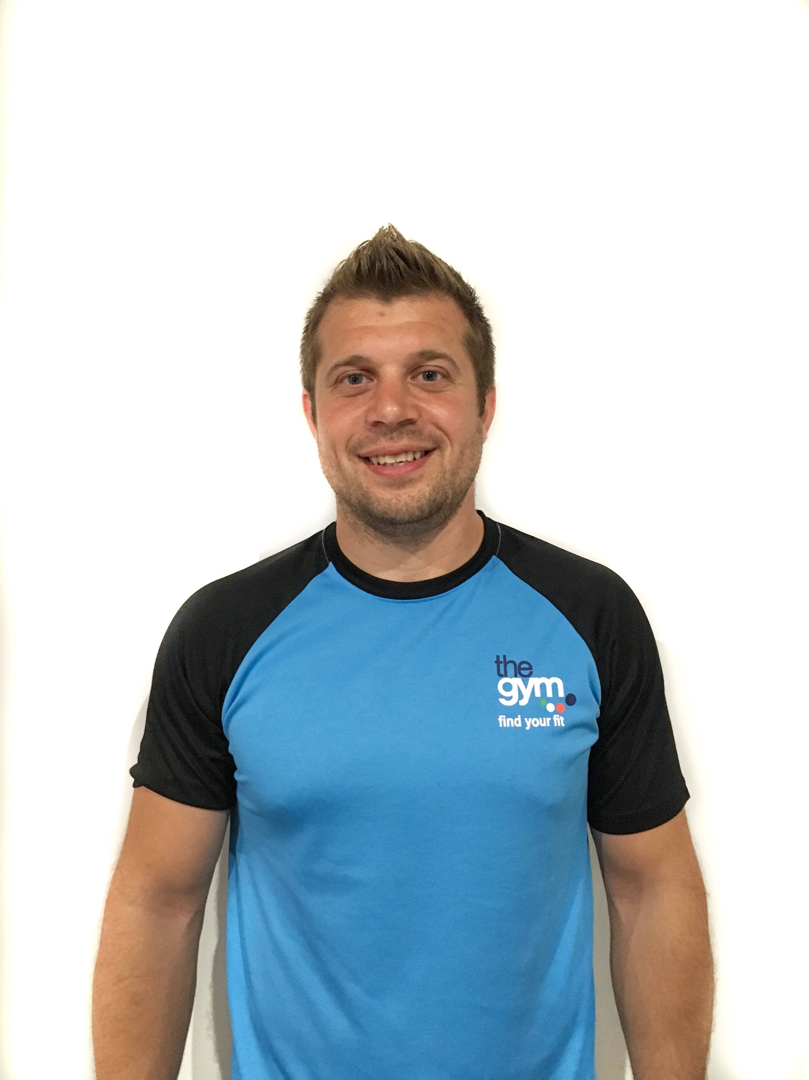

**Interests**

**HIIT**

**Weight training**

**Sport**

**Fat Loss**

**Norwich City FC**

**Email: hello@timcourridge.co.uk**

**Mobile: 07816532392**

**Results or excuses? Pick one as you can’t have both**

**Tim Courridge**

**Qualifications**

* Level 3 Personal Trainer
* Level 2 Gym Instructor
* Advanced nutrition for Sport and Exercise
* First Aid